Instruction: This is a group task.
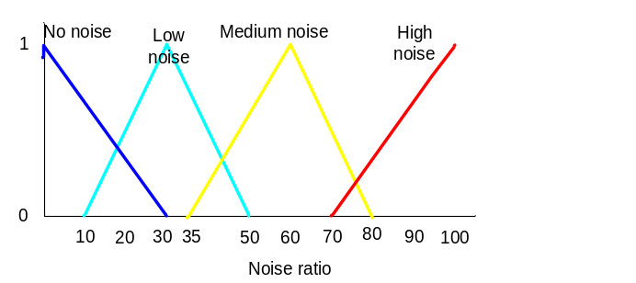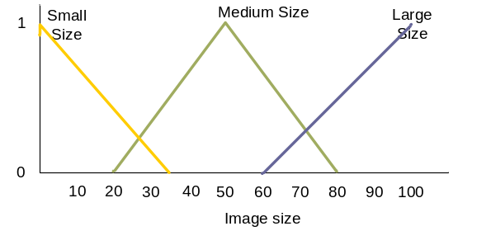
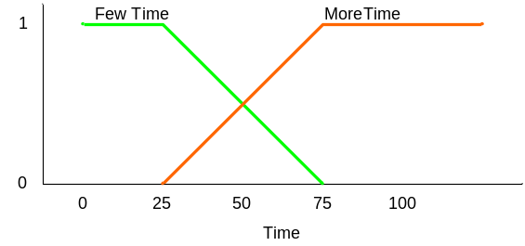

Figure 1: The system specification
IF Medium size AND No noise THEN few Time
IF Small size AND Low noise THEN few Time
IF Large size AND Low noise THEN few Time
IF Large size AND Medium noise THEN Long Time
IF Medium Load AND High noise THEN Long Time
Figure 2: New problem
Task:-
- Use Matlab Software to do this lab sheet using the Figure 1.
- Use Fazzy logic, to find a solution for the new problem when the image size is 30mp and the image noise is 45dB.
- Use the proper roles to support your solution in Figure 2.
- Find out the output for this problem ,
- Select TWO other points in the input and show the output for the new selections.
- Print Screen the input as well as the output and the roles in your report then submit it in the link available in the moodel.
- Submission Date : End of Lab Session

